**Project Design Phase-II**

**Technology Stack (Architecture & Stack)**

|  |  |
| --- | --- |
| Date | 15 October 2022 |
| Team ID | PNT2022TMID24741 |
| Project Name | Project - AI-Based localisation and classification of Skin disease with erythema. |
| Maximum Marks | 4 Marks |

**Technical Architecture:**

The Deliverable shall include the architectural diagram as below and the information as per the table1 & table 2

**Example: Order processing during pandemics for offline mode**

**Reference:** [**https://developer.ibm.com/patterns/ai-powered-backend-system-for-order-processing-during-pandemics/**](https://developer.ibm.com/patterns/ai-powered-backend-system-for-order-processing-during-pandemics/)

Guidelines:

1. Get the image from the User.
2. Use Feature Extraction method for better Classification.
3. Use several best Algorithm techniques like CNN , ANN , KNN, SVM,etc... to get accurate results.
4. By testing and get compared with trained results it predict and detect the diagram pattern.
5. Finally the Machine learning will predict with more efficiency.

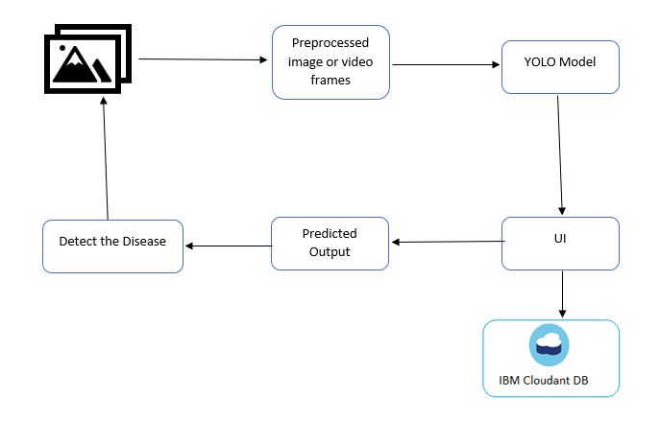

**Table-1 : Components & Technologies:**

|  |  |  |  |
| --- | --- | --- | --- |
| **S.No** | **Component** | **Description** | **Technology** |
|  | User Interface | How user interacts with application e.g.  Web UI, Mobile App, Chatbot etc. | HTML, CSS, JavaScript / Angular Js / React Js etc. |
|  | Application Logic-1 | Logic for a process in the application | Java / Python |
|  | Application Logic-2 | Logic for a process in the application | IBM Watson STT service |
|  | Application Logic-3 | Logic for a process in the application | IBM Watson Assistant |
|  | Database | Data Type, Configurations etc. | MySQL, NoSQL, etc. |
|  | Cloud Database | Database Service on Cloud | IBM DB2, IBM Cloudant etc. |
|  | File Storage | File storage requirements | IBM Block Storage or Other Storage Service or Local Filesystem |
|  | External API-1 | Purpose of External API used in the application | IBM Weather API, etc. |
|  | External API-2 | Purpose of External API used in the application | Aadhar API, etc. |
|  | Machine Learning Model | Purpose of Machine Learning Model | Object Recognition Model, etc. |
|  | Infrastructure (Server / Cloud) | Application Deployment on Local System / Cloud  Local Server Configuration:  Cloud Server Configuration : | Local, Cloud Foundry, Kubernetes, etc. |

**Table-2: Application Characteristics:**

| **S.No** | **Characteristics** | **Description** | **Technology** |
| --- | --- | --- | --- |
|  | Open-Source Frameworks | List the open-source frameworks used | Technology of Opensource framework |
|  | Security Implementations | List all the security / access controls implemented, use of firewalls etc. | e.g. SHA-256, Encryptions, IAM Controls, OWASP etc. |
|  | Scalable Architecture | Justify the scalability of architecture (3 – tier, Micro-services) | Technology used |
|  | Availability | Justify the availability of application (e.g. use of load balancers, distributed servers etc.) | Technology used |
|  | Performance | Design consideration for the performance of the application (number of requests per sec, use of Cache, use of CDN’s) etc. | Technology used |

**References:**

[1] Arifin, S., Kibria, G., Firoze, A., Amini, A., & Yan, H. (2012) “Dermatological Disease Diagnosis Using Color-Skin Images.” Xian: *International Conference on Machine Learning and Cybernetics*.

[2] Yasir, R., Rahman, A., & Ahmed, N. (2014) “Dermatological Disease Detection using Image Processing and Artificial Neural Network. “Dhaka*: International Conference on Electrical and Computer Engineering*.

[3] Santy, A., & Joseph, R. (2015) “Segmentation Methods for Computer Aided Melanoma Detection.” *Global Conference on Communication Technologies.*

[4] Zeljkovic, V., Druzgalski, C., Bojic-Minic, S., Tameze, C., & Mayorga, P. (2015) “ Supplemental Melanoma Diagnosis for Darker Skin Complexion Gradients.” *Pan American Health Care Exchanges*

[5] Suganya R. (2016) “An Automated Computer Aided Diagnosis of Skin Lesions Detection and Classification for Dermoscopy Images.” *International Conference on Recent Trends in Information Technology*.

[6] Alam, N., Munia, T., Tavakolian, K., Vasefi, V., MacKinnon, N., & Fazel-Rezai, R. (2016) “Automatic Detection and Severity Measurement of Eczema Using Image Processing.” *IEEE*.